**Project Synopsis**

**Airline Reservations**

Objective/ Vision

Echo Flights is An airline reservation website where admin can add, view, delete, update Flights and user can book a flight, as well as check availability, view flights, view transition history with Echo, & give Feedback.

Users of the System

1. Admin
2. User

Functional Requirements - Modules

* **Admin**
  + Add Flight
  + Add Airport
  + Remove Flight
  + Remove Airport
  + Update Flight
  + Update Airport
  + Flight information
* **User**
  + Search Flights
  + Check Seat Availability
  + Seat Booking
  + Transaction History

Technologies/Tools to be used Developed By:

1. Angular Vikas Dhiman(Team Lead)
2. JDK 8 and Above Prajjwal Jaiswal
3. Visual Studio code Prateek Sharma
4. Spring Tool Suite 4 Yogesh Bora
5. Postman
6. NPM
7. MySQL for database

Screenshots

Home Page

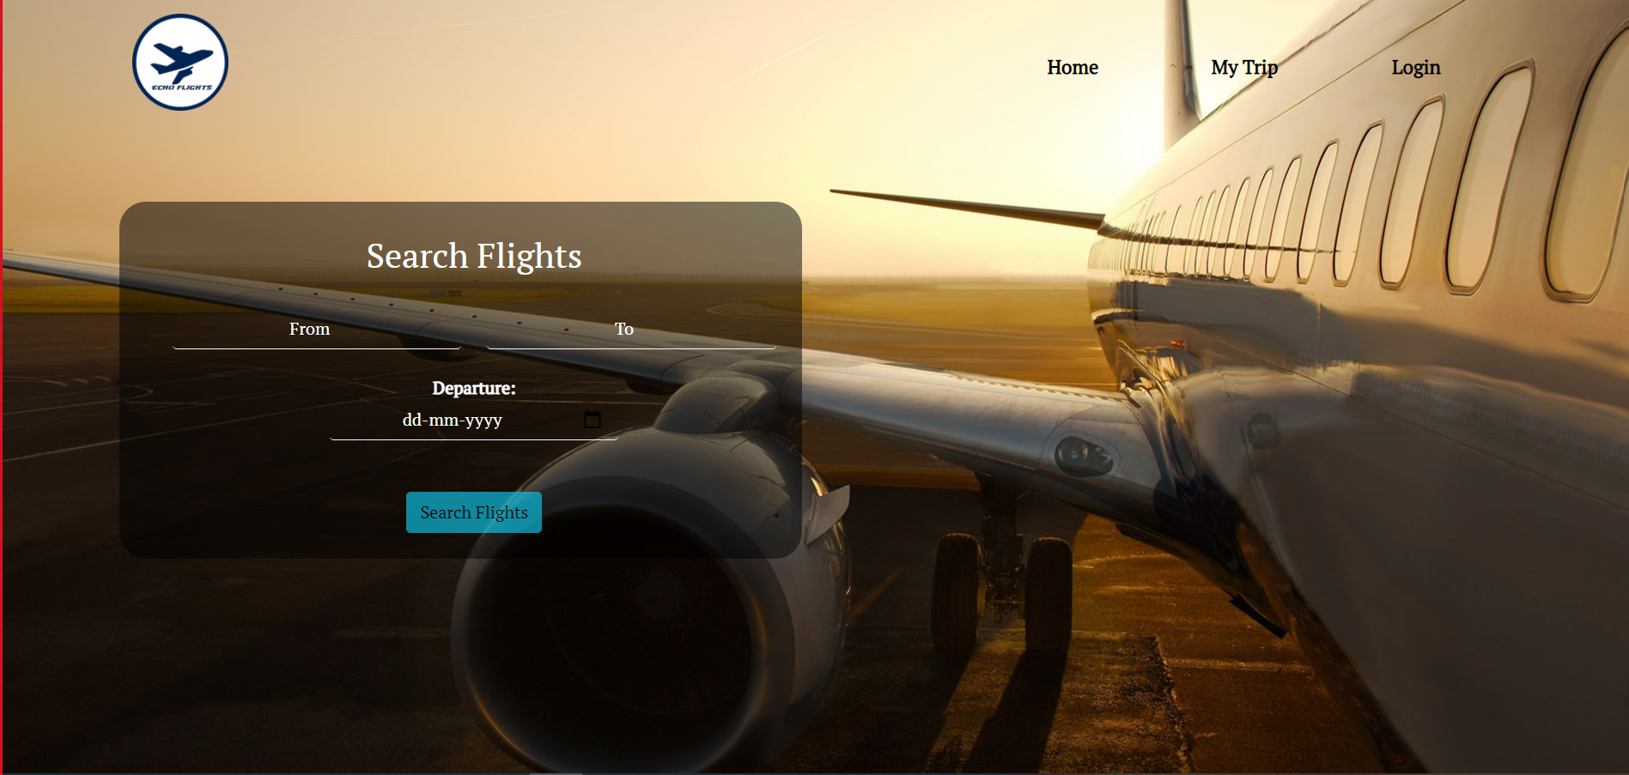

Login Page

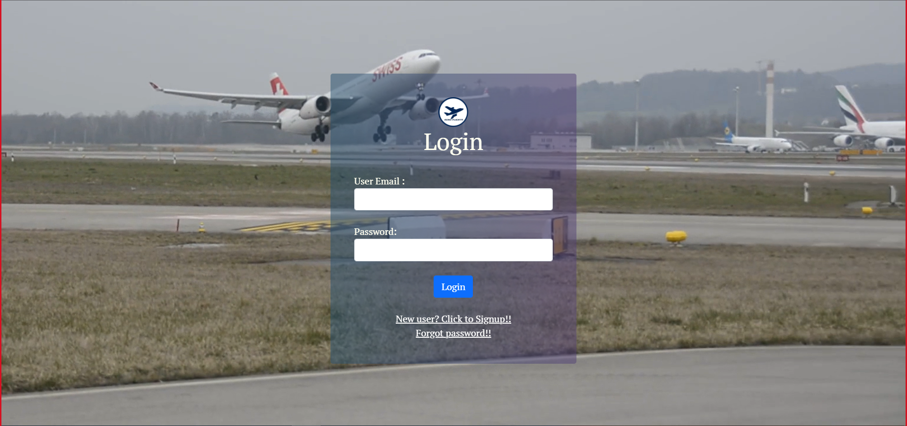

Sign-up Page

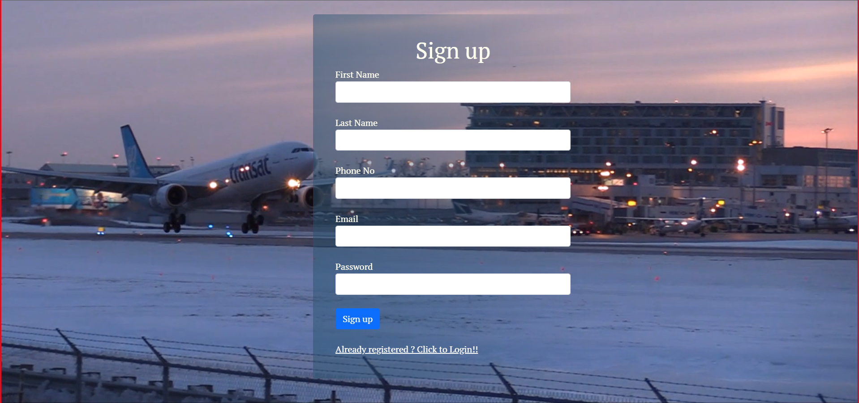

Reset Password

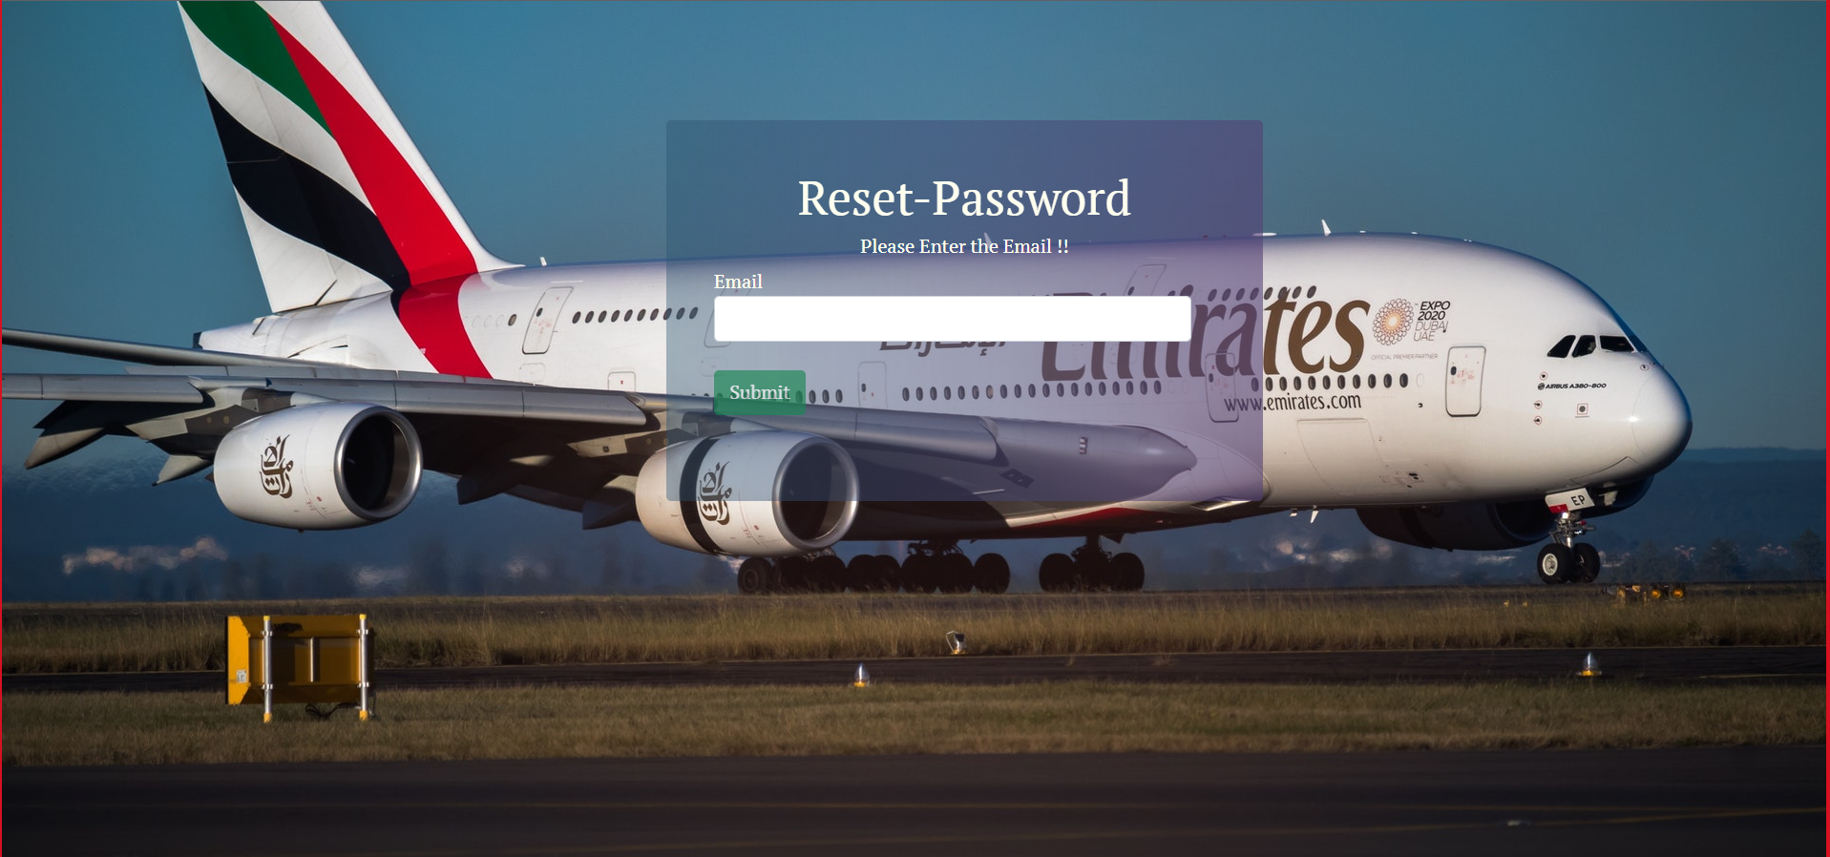

Home Page (Admin)

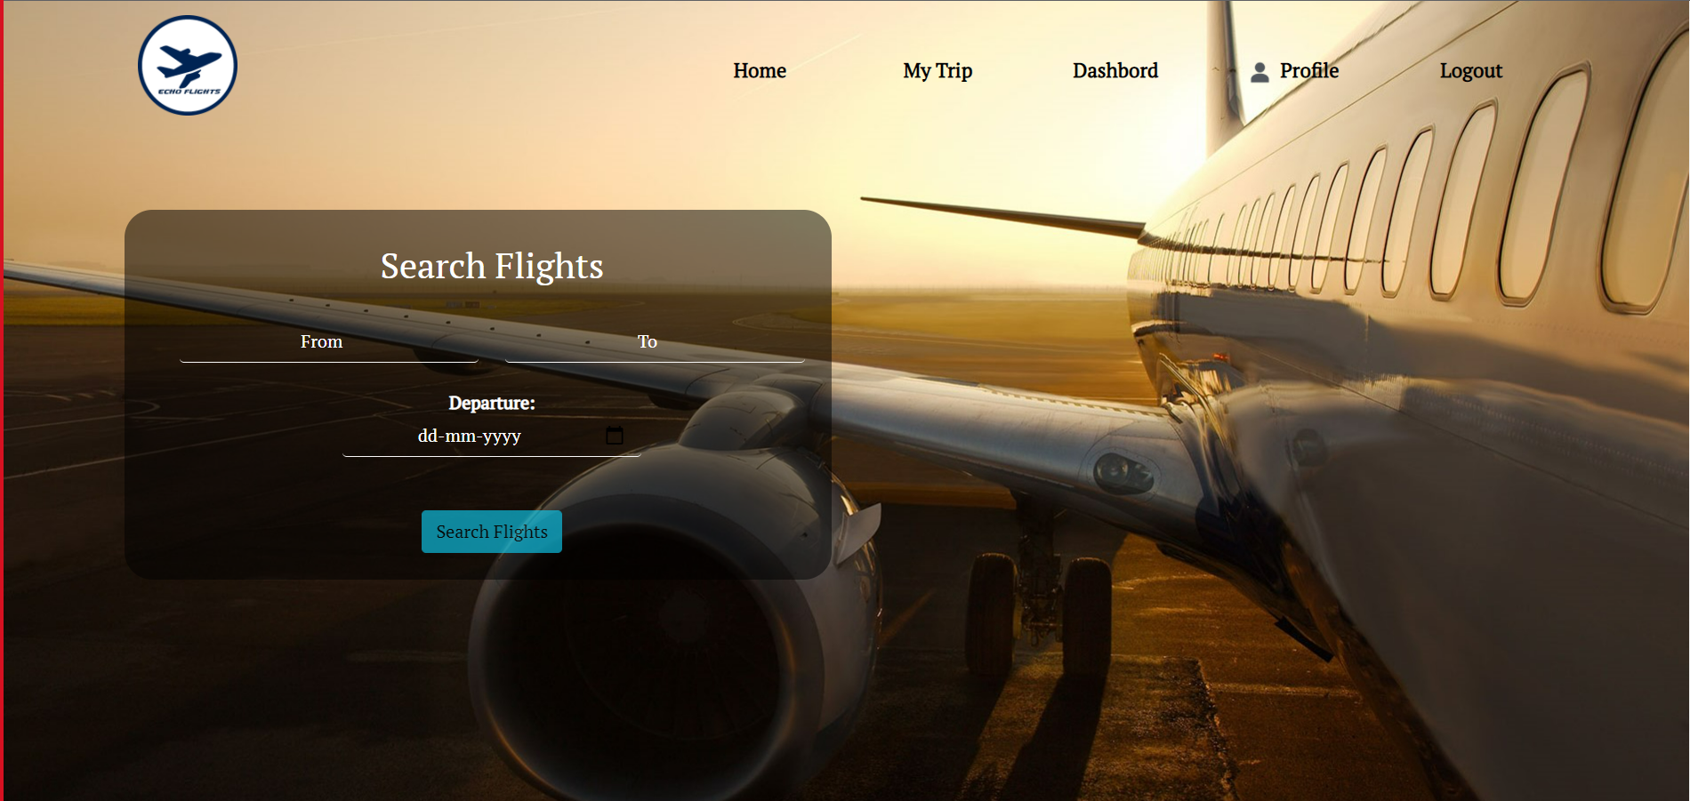

Admin Dashboard

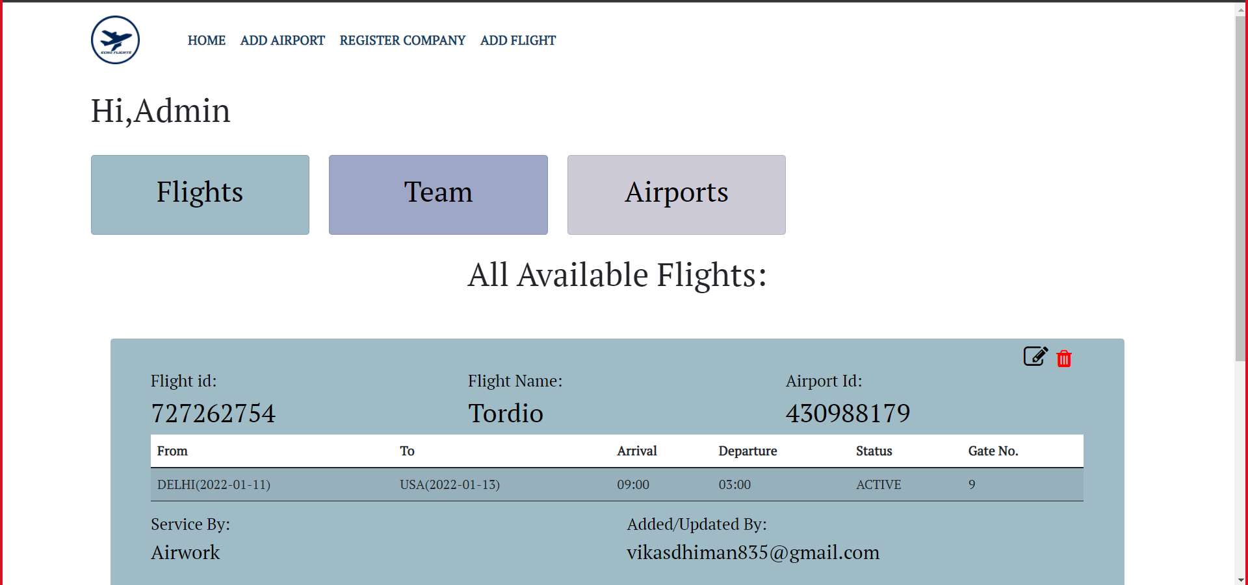

Add Flight

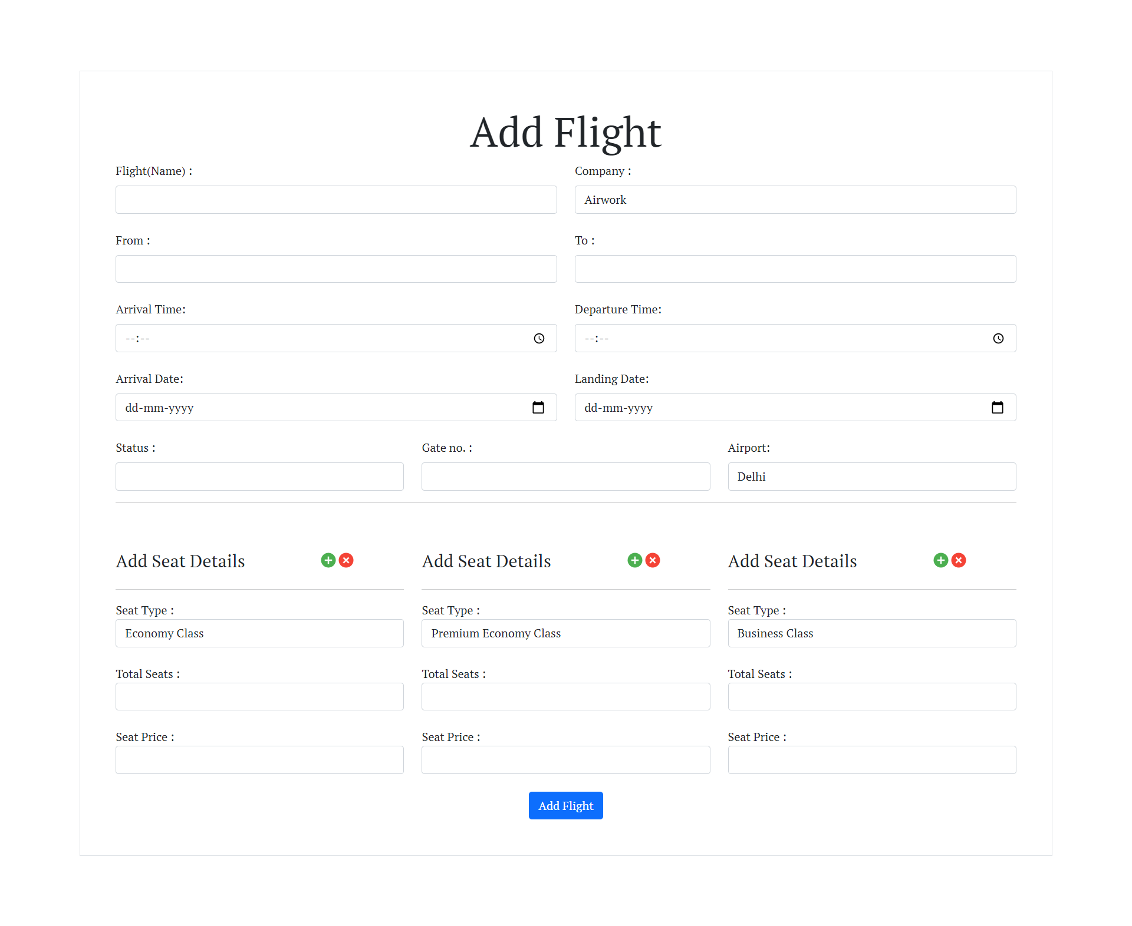

User Home Page

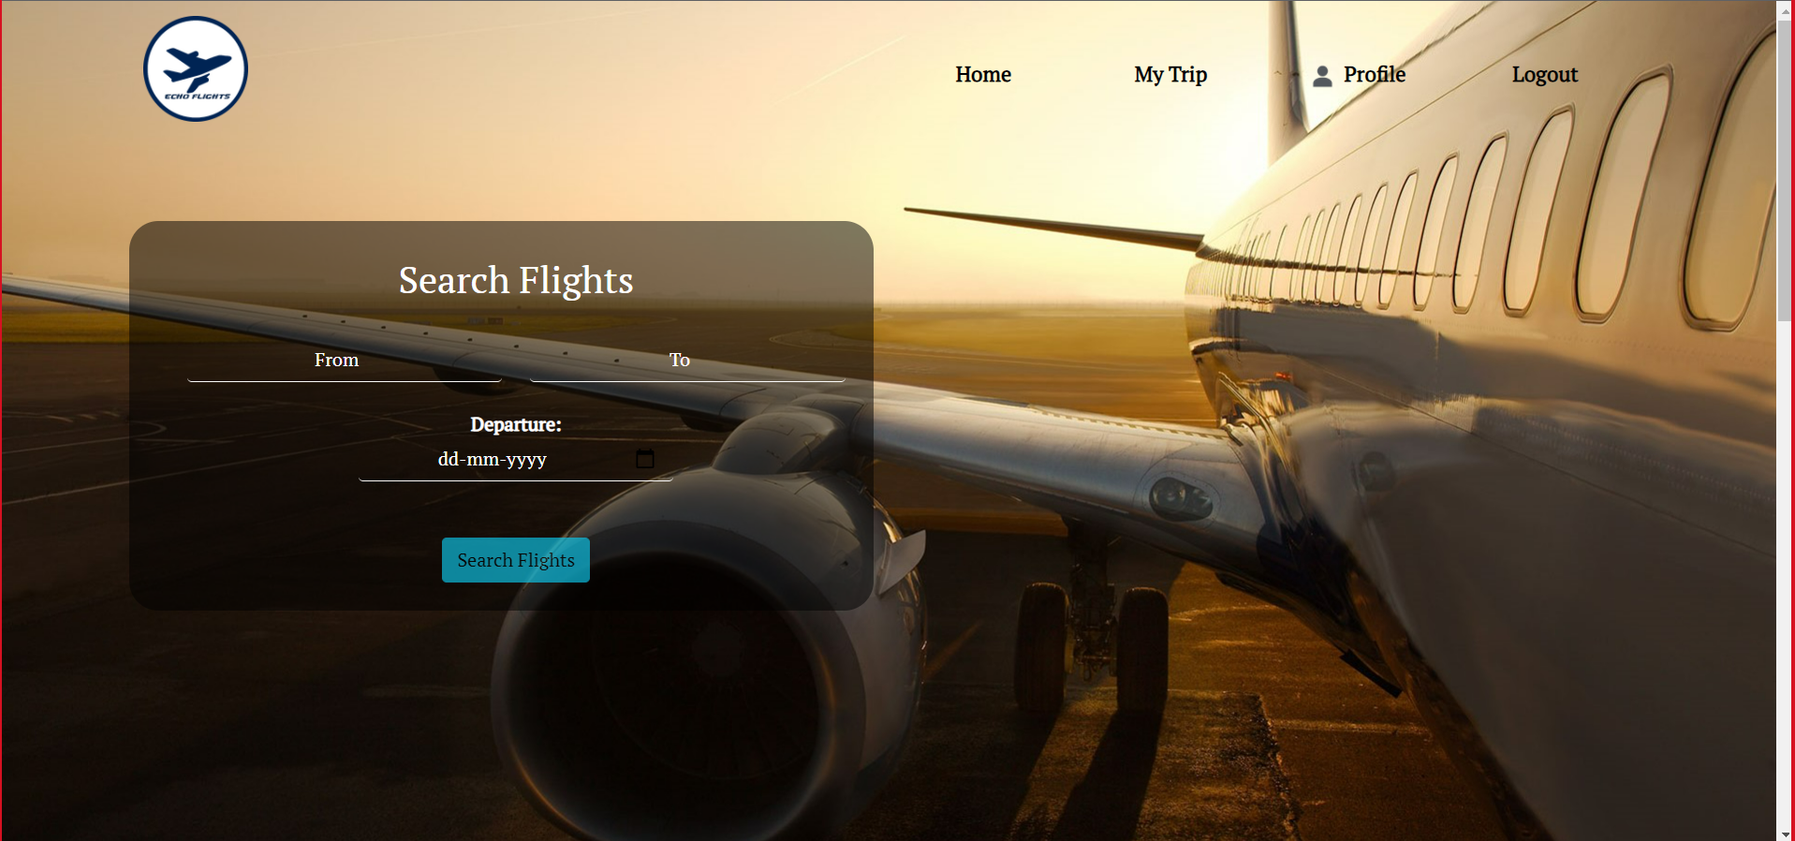

Profile Page

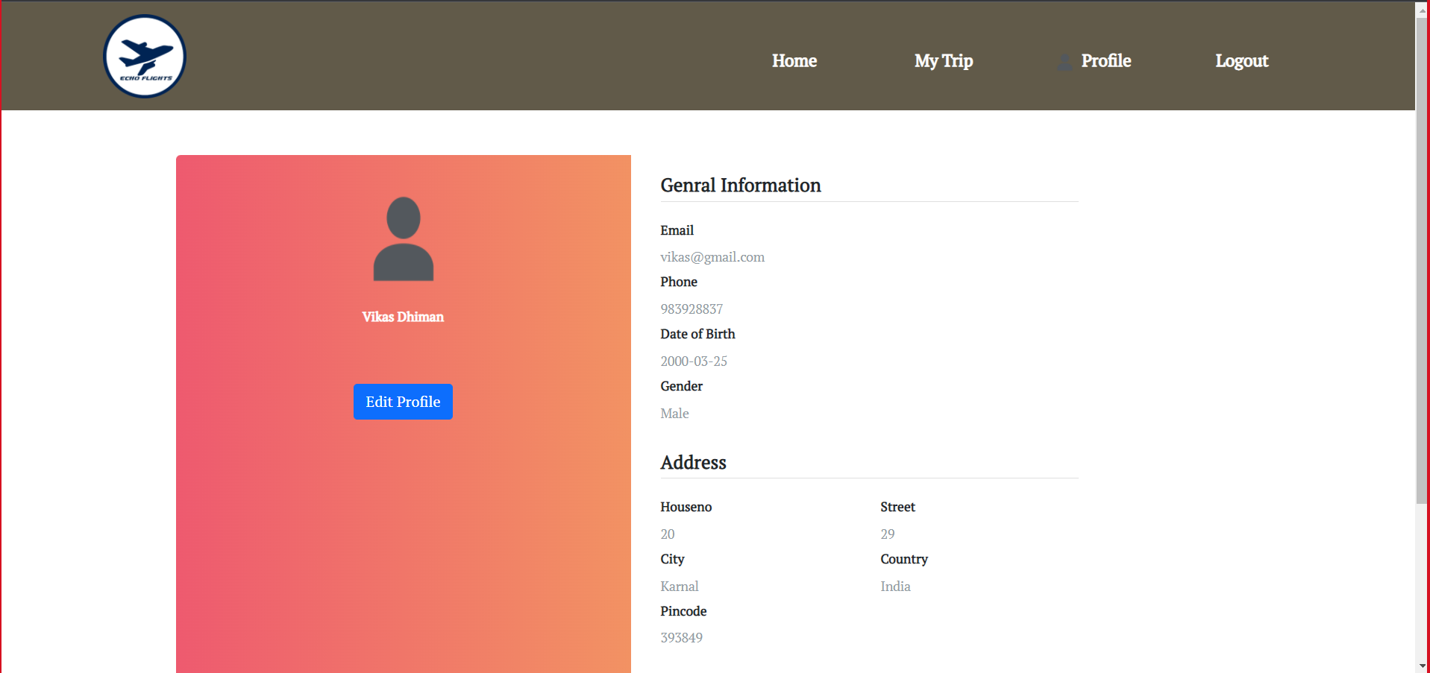

Search Flight

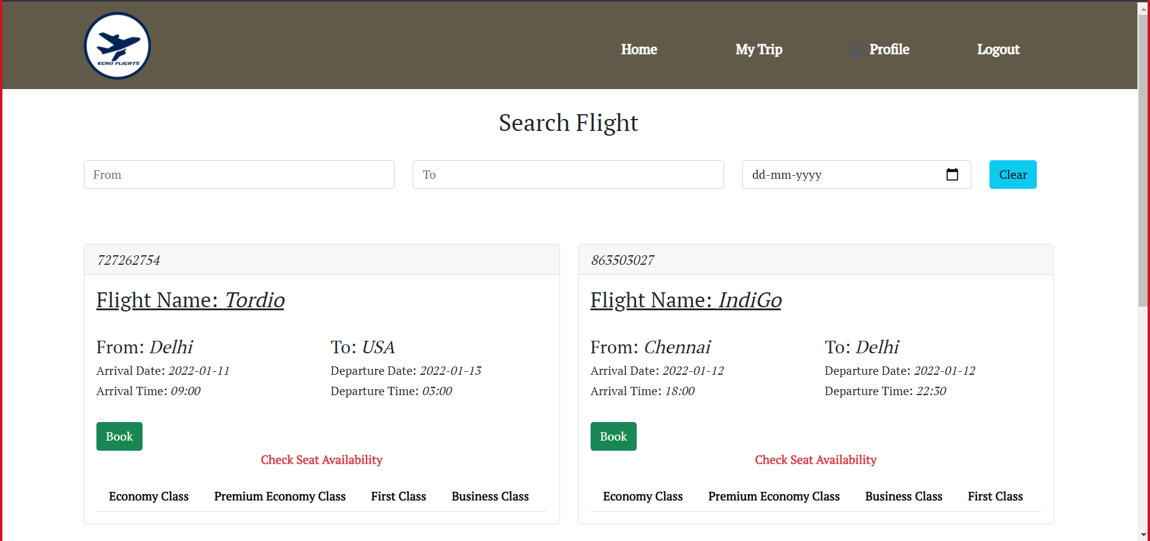

Add Passenger

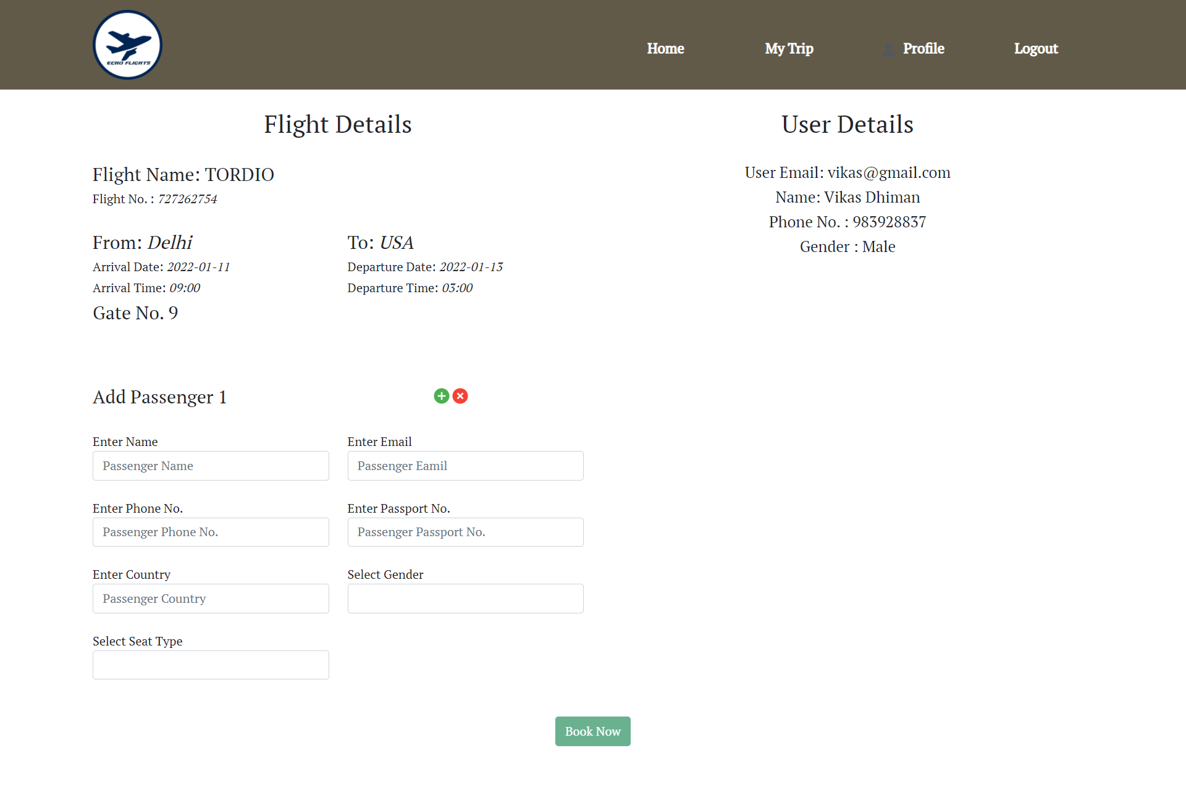

Confirmation Page

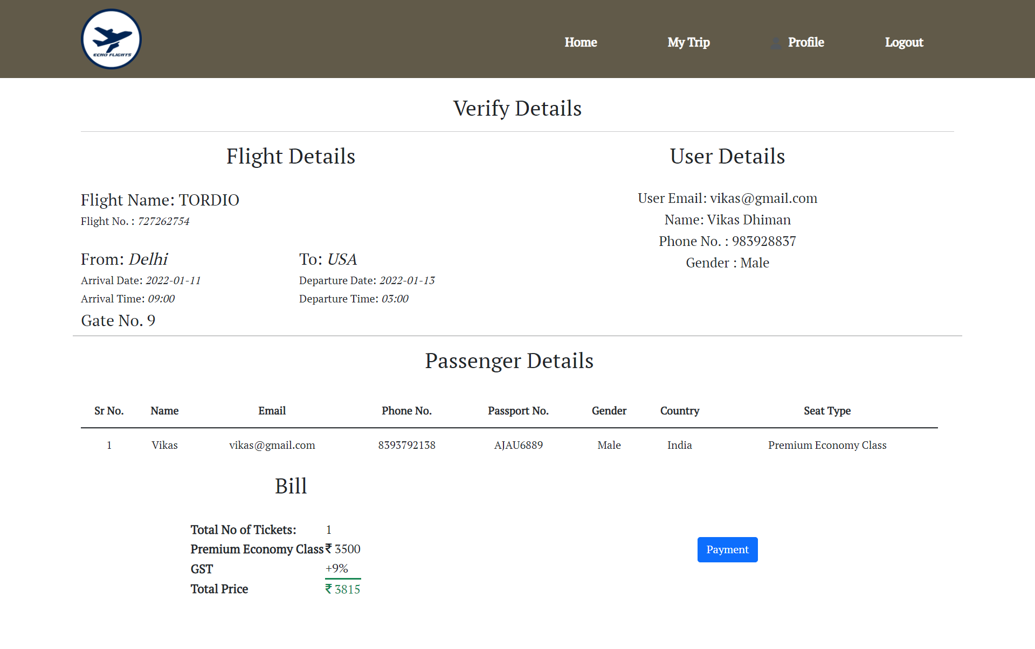

Payment Page

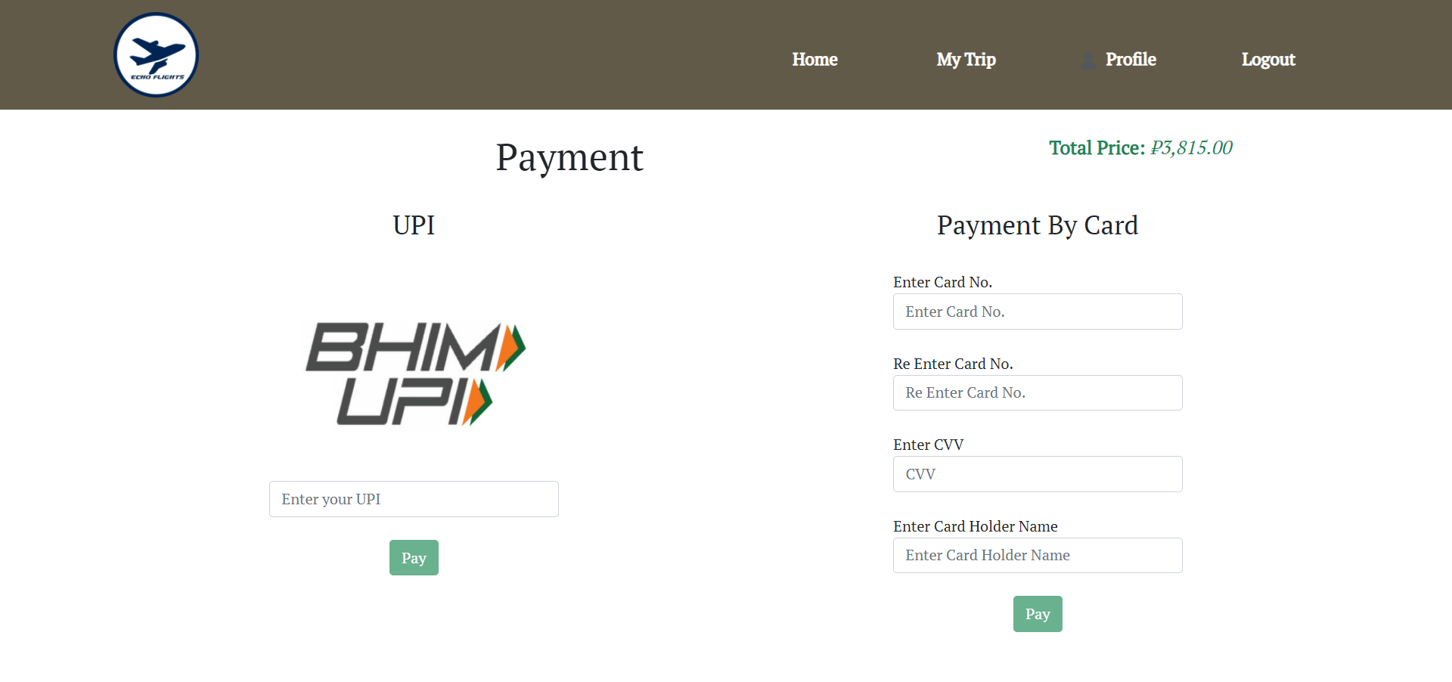

Ticket Booking Page: Success

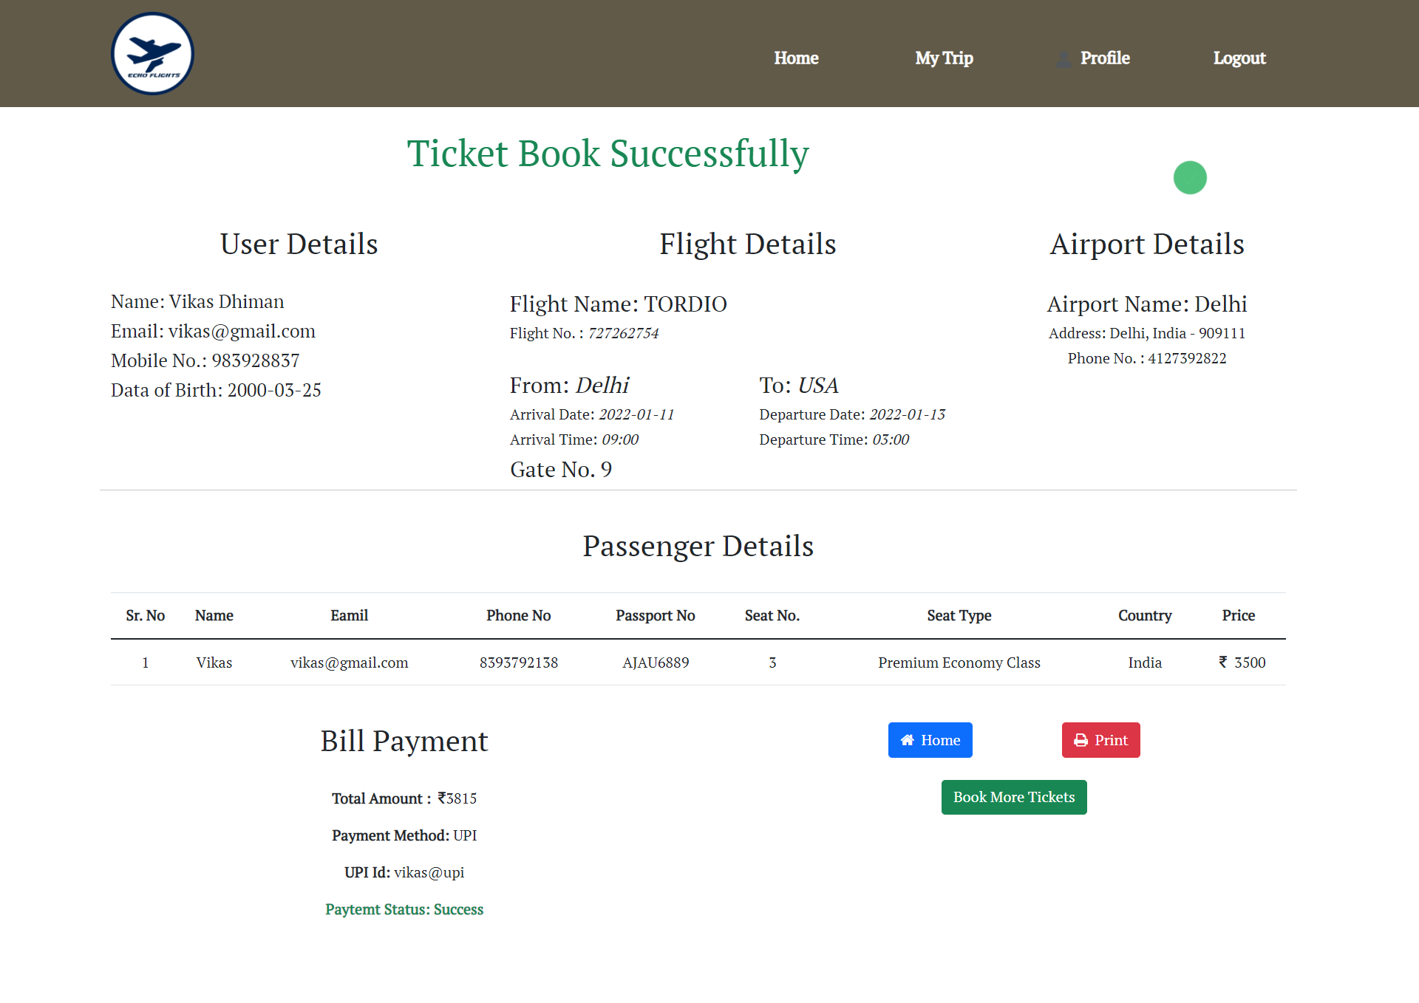

Booking History

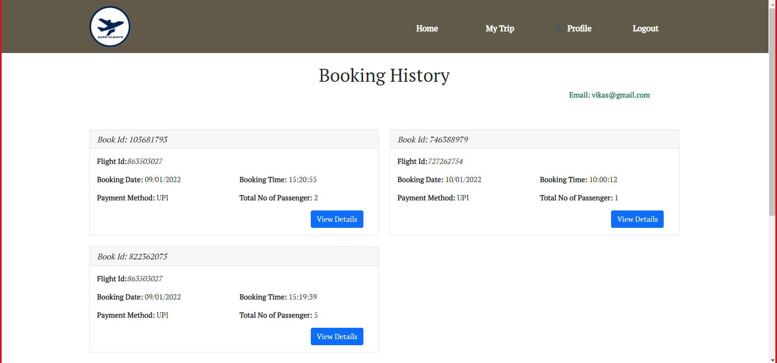

Ticket Details

